RIGA TECHNICAL UNIVERSITY

FACULTY OF COMPUTER SCIENCE AND INFORMATION TECHNOLOGY

INSTITUTE OF APPLIED COMPUTER SYSTEMS

Practical assignment #3

“Data Models in Database Systems”

**“Document databases and hierarchical data model”**

**Student:**

Student Card No: 211ADB068

2023/ 2024 study year

**Content**

1 **Practical Work Requirements** 3

2 **Task** 4

3 **Queries** 5

4 **MongoDB query** 7

5 **Conclusions** 8

# Practical Work Requirements.

1. Store the other XML document in a native database, such as eXistDB. Run the queries in

your variation.

The minimal requirements: All queries run.

The maximal requirements: Appropriate constructs used, XQuery used in at least one query.

2. Option 1: Create appropriate table and insert the XML file into the Oracle database and

run at least one query on that table! Option 2: transform data from XML to JSON and

read that into the MongoDB. Run one query of your variation on that file!

The minimal requirements: Everything implemented in Oracle with XMLType.

The maximal requirements: Either some more complex constructions in Oracle that are

semantically well explained, or everything implemented in MongoDB (Oracle not needed in this

case).

# Task

Queries:

1. Retrieve the email of the company with index 10 (not id!)

2. Retrieve all information about the company with index (not id!) 28

3. Get only codes of all products sold by the company "Eabox".

4. Get all information about products of category A4 which are sold by company with id = 28. Result must contain multiple "product" nodes with full information inside.

# Queries

Task1:

xquery version "3.1";

/companies/company[position() = 10]/email

/companies selects the element companies and under it, /company selects all company data, [position() = 10] filters for the company at position 10, and /email selects the email data within that company.

Task2:

xquery version "3.1";

/companies/company[position() = 28]

Same as in Task1, /companies selects the root element, /company selects all company data, [position() = 28] filters for the company at position 28.

Task3:

xquery version "3.1";

/companies/company[name = 'Eabox']/products/product/code

/companies selects the root element and under it, /company selects all company, [name = 'Eabox'] filters for the company with the specific name, /products/product selects all product elements under that company, and /code selects the code data within each product.

Task4:

xquery version "3.1";

/companies/company[@id = 28]/products/product[@category = 'A4']

/companies selects the root element, /company selects all company, [id = 28] filters for the company with the specific ID, /products/product[category = 'A4'] selects all product data under that company with the name/category “A4”.

Example images from ExistDB.

# MongoDB Query

MongoDB query:

db.database.find().skip(27).limit(1)

This MongoDB query is used to skip the first 27 documents and retrieve the next document, which is selecting the document at position 28.

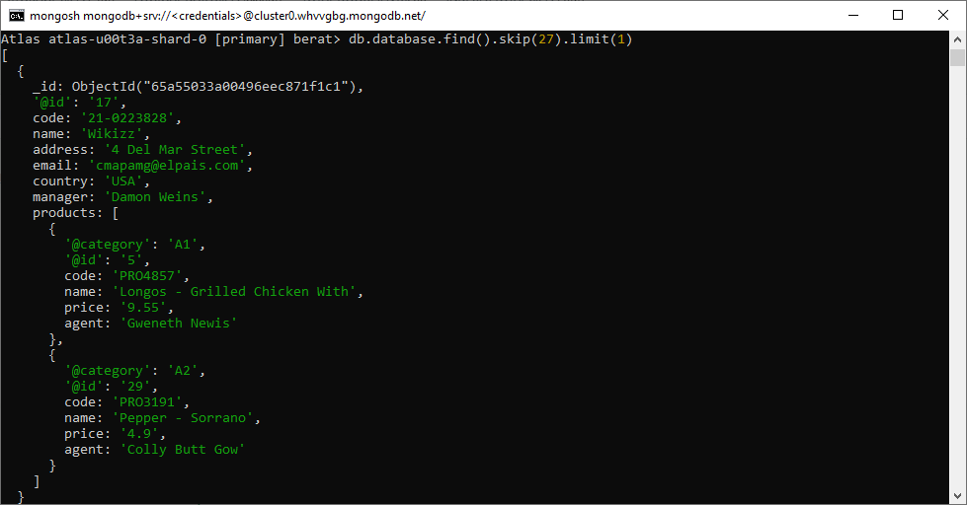

# Conclusion

In this assignment, I have achieved the experience of setting up the existDB and MongoDB environments. Additionally, I have learned how to save .XML files in existDB and create a query for the existing .XML file. Also, with the help of public websites which help to convert .xml to .JSON files, I easily converted my .XML file to be able to work on MongoDB. I chose MongoDB because I had a couple errors with Oracle software in my laptop even though I downloaded Hyper-V virtual windows 10 environment it did not work. Then I decided to work with MongoDB. First of all, I created a MongoDB account and downloaded the needed file. I chose to use CMD because I feel more comfortable with CMD, and it was easier for me to use because I just needed to create 1 query. Making connection in MongoDB was way easier than creating an account for Oracle, thanks to this assignment I also met with MongoDB environment. I believe that I gained valuable experience with this practical task.